

**وحدة ضمان الجودة**

Quality Assurance Unit

Accredited August 2014

Reaccredited 2020

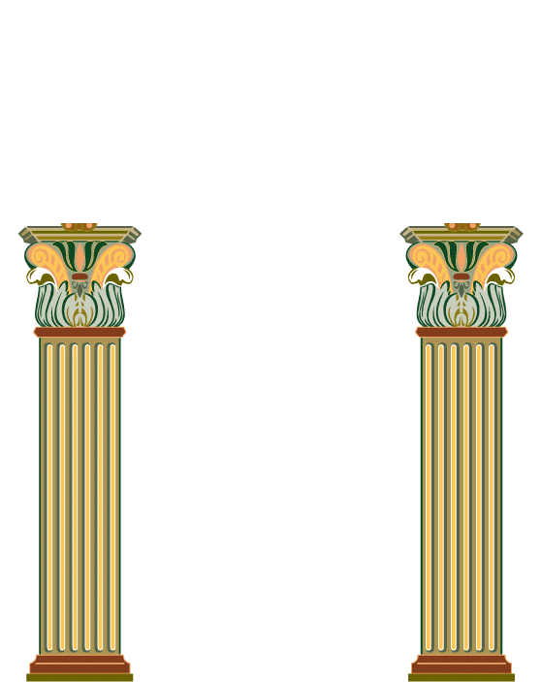

كلية التمريض

***Course Portfolio Contents for Nursing Course***

Academic year: ………**/**……………. Course name and code: ………………….

| **Comment** | **Unfulfilled**  **0** | **Incompletely fulfilled**  **1** | **Fulfilled**  **2** | **Items of Course Portfolio Contents** |
| --- | --- | --- | --- | --- |
|  |  |  |  | **1. Course specification:** |
|  |  |  |  | 1.1 Approved copy of course specification  * |
|  |  |  |  | 1.2 Evidences for course specification students’ announcement |
|  |  |  |  | 1.3 Course syllabus |
|  |  |  |  | **2. Action plan of the course:** |
|  |  |  |  | 2.1 Approved copy of course teaching plan * |
|  |  |  |  | 2.2 List of students names registered in the course |
|  |  |  |  | 2.3 Students distribution (groups) in clinical areas |
|  |  |  |  | 3. Approved blueprint for the course * |
|  |  |  |  | **4. Course schedules:** |
|  |  |  |  | 4.1 Approved copy of faculty lectures schedule (theoretical & clinical) |
|  |  |  |  | 4.2 Approved student clinical rotation * |
|  |  |  |  | 5. Approved letters of clinical training |
|  |  |  |  | 6. Education and students report about the achievement of hybrid education * |
|  |  |  |  | 7. Sample of student learning and teaching activities  (Hard copy or CD) |
|  |  |  |  | **8. Assessment methods of the course:** |
|  |  |  |  | 8.1 Quizzes & its model answers |
|  |  |  |  | 8.2 Mid-term exam with students’ signature & its model answer |
|  |  |  |  | 8.3 Viva cards of oral exam & its model answers |
|  |  |  |  | 8.4 OSCE exam (practical exam) & its model answer |
|  |  |  |  | 8.5 Final exam & its model answer |
|  |  |  |  | 9. Approved final exam papers analysis report * |
|  |  |  |  | 9.1 Corrective actions for final exam papers * |
|  |  |  |  | 10. External evaluator feedback |
|  |  |  |  | 11. Approved copy of students evaluation grades |
|  |  |  |  | 11.1. Evidence about students’ announcement regarding semester work grades |
|  |  |  |  | **12. Mechanism for dealing with defaulting students:** |
|  |  |  |  | 12.1 Approved mechanism of department for dealing with defaulting students * |
|  |  |  |  | 12.2 Approved Plan and procedure for defaulting students in the course * |
|  |  |  |  | 12.3 Approved Report of defaulting students plan implementation * |
|  |  |  |  | 12.4 Approved copy of students warning letters for  their absence * |
|  |  |  |  | **13. Mechanism for dealing with excellent students:** |
|  |  |  |  | 13.1 Approved mechanism of department for dealing with excellent students * |
|  |  |  |  | 13.2 Evidence of excellent students plan implementation |
|  |  |  |  | 14.**Students opinion form in the course** |
|  |  |  |  | 14.1 Report of students’ opinion in the course |
|  |  |  |  | 15. Approved Corrective actions for the course and improvement plan  * |
|  |  |  |  | **16. Course report:** |
|  |  |  |  | 16.1 Approved previous course report for 2 years |
|  |  |  |  | 16.2Approved recent course report * |

**\* Approved item should be attached with evidence from department council .**

**Any additional document should be added**