

**وحدة ضمان الجودة**

Quality Assurance Unit

Accredited August 2014

Reaccredited 2020

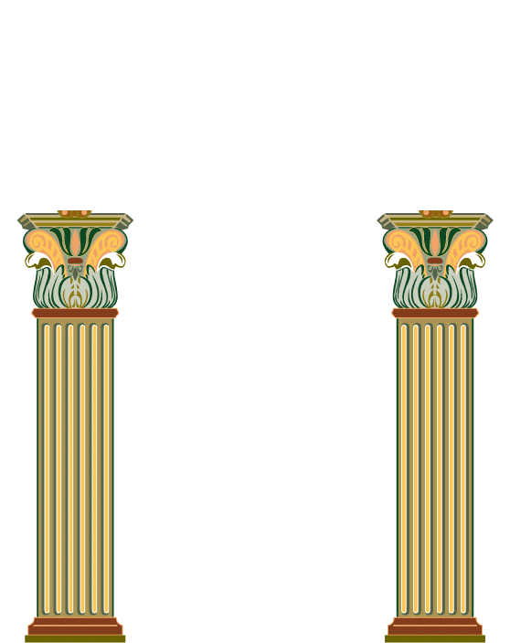

كلية التمريض

***Course Portfolio Contents for Medical and Behavioral Course***

Academic year: ………**/**……………. Course name and code: ………………….

| **Comment** | **Unfulfilled**  **0** | **Incompletely fulfilled**  **1** | **Fulfilled**  **2** | **Items of Course Portfolio Contents** |
| --- | --- | --- | --- | --- |
|  |  |  |  | **1. Course specification:** |
|  |  |  |  | 1.1 Approved copy of course specification * |
|  |  |  |  | 1.2 Evidences for course specification students’ announcement |
|  |  |  |  | 1.3. Course syllabus |
|  |  |  |  | **2. Action plan of the course:** |
|  |  |  |  | 2.1 Approved copy of course teaching plan * |
|  |  |  |  | 2.2 List of students names registered in the course |
|  |  |  |  | 3. Approved blueprint for the course * |
|  |  |  |  | **4. Course schedules:** |
|  |  |  |  | 4.1 Approved copy of faculty lectures schedule |
|  |  |  |  | 5. Approved Education and students report about the achievement of hybrid education * |
|  |  |  |  | 6. Sample of student learning and teaching activities (Hard copy or CD) |
|  |  |  |  | **7. Assessment methods of the course:** |
|  |  |  |  | 7.1 Quizzes & its model answers |
|  |  |  |  | 7.2 Mid-term exam with students’ signature & its  model answer |
|  |  |  |  | 7.3 Viva cards of oral exam & its model answers |
|  |  |  |  | 7.4 Final exam & its model answer |
|  |  |  |  | 8. Approved final exam paper analysis report * |
|  |  |  |  | 8.1 Corrective actions for final exam papers * |
|  |  |  |  | 9. External evaluator feedback form |
|  |  |  |  | 10. Approved copy of students evaluation grades |
|  |  |  |  | 10.1 Evidence about students’ announcement regarding semester work grades |
|  |  |  |  | **11. Mechanism for dealing with defaulting students:** |
|  |  |  |  | 11.1 Approved mechanism of department for dealing with defaulting students * |
|  |  |  |  | 11.2 Plan and procedure for defaulting students  in the course * |
|  |  |  |  | 11.3 Report of defaulting students plan  implementation * |
|  |  |  |  | 11.4 Approved copy of students warning letters  for their absence * |
|  |  |  |  | **12. Mechanism for dealing with excellent students:** |
|  |  |  |  | 12.1 Approved mechanism of department for  dealing with excellent students * |
|  |  |  |  | 12.2 Evidence of excellent students plan  implementation |
|  |  |  |  | **13.Students opinion form in the course** |
|  |  |  |  | 13.1 Report of students’ opinion in the course |
|  |  |  |  | 14 .Approved Corrective actions for the course  and improvement plan  * |
|  |  |  |  | **15. Course report:** |
|  |  |  |  | 15.1 Approved previous course report for 2  Years |
|  |  |  |  | 15.2 Approved recent course report * |

**\* Approved item should be attached with evidence from department council**

**Any additional documents should be added**